Project Report

Key Sensei: Touch Typing Website

Prepared for

Continuous Assessment 3

Spring 2024

Advanced Web Development (INT222)

### 

Lovely Professional University

Jalandhar, Punjab, India.

Submitted to:

Submitted by:

Registration No:

Section:

Declaration

I hereby declare that the project work entitled “**Key Sensei: Touch Typing Website**” is an authentic record of our own work carried out as requirements of Continuous Assessment-03 for the grading of course, **Advanced Web Development (INT222)** in B. TECH Computer Science Engineering from Lovely Professional University, Phagwara, under the guidance of, during Spring 2024. All the information furnished in this project report is based on my own intensive work and is genuine.

Name of Student:

Registration Number:

(Signature of Student)

Date: 23 April, 2024

Certificate

This is to certify that the declaration statement made by the student is correct to the best of my knowledge and belief. He /She have completed this Project under my guidance and supervision. The present work is the result of his/her original investigation, effort and study. No part of the work has ever been submitted for any other degree at any University. The Project is fit for the submission and partial fulfilment of the conditions for the grading of course, **Advanced Web Development (INT222)** in B. TECH Computer Science Engineering from Lovely Professional University, Phagwara

Faculty Name:

**School of Computer Science and Engineering,**

Lovely Professional University,

Phagwara, Punjab.

Signature:

Date:

Table of Contents

1. Introduction

2. Purpose

3. Scope

4. Existing System

4.1. Introduction

4.2. What’s new in the system to be developed

5. Problem Analysis

5.1. Product definition

5.2. Feasibility Analysis

5.3. Project Plan

6. Software Requirement Analysis

* 1. General Description
  2. Specific Requirements
     1. External Interface Requirements
        1. User Interface
        2. Hardware Interface
     2. Functional Requirements
     3. Non-Functional Requirements
        1. Performance
        2. Reliability
        3. Availability
        4. Security
        5. Maintainability
        6. Portability

1. Design
   1. System Design
   2. Data Flow Diagrams (DFDs)
2. Dependencies
3. Assumptions and Constraints
4. Source Code
5. System Snapshots

# 1. Introduction

* The touch-typing website aims to assist students, teachers, employees, and beginner programmers in improving their typing speed and accuracy.
* Users can practice typing by generating random paragraphs with various settings such as time limits, and word limits.

# 2. Purpose

* The touch-typing website is designed to assist individuals, including students, teachers, employees, and beginner programmers, in improving their typing speed and accuracy.
* By providing a platform for practicing typing with customizable parameters such as paragraph content, time limits, and word limits, the website aims to:
  + Enhance users' typing skills and proficiency with keyboard input.
  + Increase users' comfort and familiarity with keyboard layouts and typing techniques.
  + Reduce users' work time by improving typing speed and accuracy.
  + Boost users' overall performance in tasks that require keyboard input, such as writing, coding, and data entry.

# 3. Scope

* The website will feature a login system connected to a database to store user information and typing statistics.
* Users will be able to select different categories of paragraphs to practice typing.
* After completing a typing test, users will receive feedback on their mistakes and typing speed in words per minute (WPM).
* The website will include features such as timers (15, 30, and 60 seconds) and word limits (25, 60, and 120 words).

# 4. Existing System

## 4.1. Introduction

Prior to this system, touch-typing practice websites existed, but with limited features and user interactivity. They often lacked real-time feedback, adjustable test parameters, or a blurred interface to discourage looking at the keyboard.

## 4.2. What’s new in the system to be developed

The system being developed introduces several new features:

* Real-time feedback during typing tests (green for correct, red for wrong)
* Blurred typing interface to encourage focus
* Adjustable test parameters such as timer and total words
* Keyboard layout display for reference

# 5. Problem Analysis

## 5.1. Product Definition

The product is a touch-typing website designed to assist users in improving their typing skills. It offers an interactive platform for users to practice typing with various settings such as paragraph content, time limits, and word limits. By providing a customizable and engaging typing experience, the website aims to cater to students, teachers, employees, and beginner programmers who seek to enhance their typing speed and accuracy.

## 5.2. Feasibility Analysis

The feasibility of the touch-typing website project was evaluated across various aspects:

**Technical Feasibility**:

* Technology Stack: Node.js, Express, MongoDB, HTML, CSS, JavaScript, Bootstrap, jQuery.
* Security: User data encryption, secure authentication.
* Interactive Interface: Blurred typing interface for focus, real-time feedback, keyboard layout display.

**Economic Feasibility**:

* Resource Requirements: Developers skilled in Node.js, Express, MongoDB.
* Infrastructure Costs: Hosting, domain, server resources.
* Cost-Benefit Analysis: Potential benefits include improved typing skills, time savings in work tasks.

**Operational Feasibility**:

* Ease of Use: Intuitive interface for all skill levels.
* Maintenance: Routine updates, database management.
* Scalability: Ability to handle increasing user traffic.

## 5.3. Project Plan

The project plan outlines the development roadmap, resource allocation, and milestones for the touch-typing website:

**Planning Phase**:

* Define project scope, requirements, and features.
* Research and select appropriate technologies.

**Development Phase**:

* Build user authentication system (Node.js, Express, MongoDB).
* Implement typing practice features (timer, word limits, feedback).
* Design and develop front end with Bootstrap, jQuery for interactivity.

**Testing and Refinement**:

* Conduct thorough testing for functionality and user experience.
* Gather feedback and make necessary improvements.

**Deployment**:

* Prepare for hosting on a reliable server.
* Ensure security measures are in place (data encryption, secure authentication).

**Maintenance**:

* Regular updates, bug fixes, and database management.

**Resource Allocation**:

* Time Allocation: Estimated time for each phase of development and testing.
* Budget: Allocate funds for hosting, domain, and development resources.

**Milestones**:

* User Authentication System
* Typing Practice Features Implementation
* Frontend Design and Interactivity
* Testing and Refinement
* Deployment and Launch
* Post-Launch Maintenance

# 6. Software Requirement Analysis

## 6.1 General Description

* The touch-typing website requires a frontend built with Bootstrap and jQuery for a responsive and interactive user interface. The backend is developed using Node.js, Express, and Mongoose for MongoDB integration.

## 6.2 Specific Requirements

## 6.2.1 External Interface Requirements

## 6.2.1.1 User Interface

## Interactive and Responsive Design using Bootstrap:

## The website interface should be responsive, adapting to various screen sizes and devices.

## Bootstrap components should be utilized for a consistent and visually appealing design.

## Blurred Typing Interface for Focus:

## The typing interface should be initially blurred to encourage users to focus on the screen and not the keyboard.

## It should become clear and ready for typing when the user clicks on it.

## Keyboard Layout Display:

## A visual representation of the keyboard layout should be provided on the screen.

## This display should highlight keys pressed during the typing test for easy reference.

## Menu Bar for Test Settings:

## A menu bar should offer options to adjust the test settings.

## Users should be able to change the test timer and total words for each test.

## 6.2.1.2 Hardware Interface

**Standard Web Browser Compatibility:**

* The touch typing website should be compatible with standard web browsers such as Chrome, Firefox, Safari, and Edge.

## 6.2.2 Functional Requirements

## User Registration:

## Users can sign up for an account to access the typing practice features.

## Account creation requires providing necessary information such as username, email, and password.

## User Authentication:

## Registered users can log in to access their profile and typing statistics.

## User credentials are verified against the database for authentication.

## Typing Practice:

## Users can select categories of paragraphs to practice typing.

## Options include paragraphs with punctuation, numbers, and different time/word limits.

## A timer countdown will begin when the typing practice starts.

## Users can type the displayed paragraph within the specified time and word limit.

## Feedback and Results:

## After completing a typing test, users receive feedback on their typing accuracy and speed.

## Mistakes in typing are highlighted, and the user's typing speed is measured in WPM.

## User Profile:

## Users can view their typing statistics and progress in their profile.

## Statistics include WPM, accuracy, and historical performance.

## 6.2.3 Non-Functional Requirements

## 6.2.3.1 Performance

**Smooth and Responsive Typing Interface:**

* The typing interface should respond promptly to user input without lag.
* Smooth transitions between letters and feedback for a seamless user experience.

**Efficient Timer Functionality:**

* The timer should accurately count down the set duration of the typing test.
* Users should receive clear notifications when the time is up.

## 6.2.3.2 Reliability

**Accurate Tracking of Typing Accuracy:**

* The system should reliably track each keystroke to provide accurate feedback on typing accuracy.
* Results should reflect the user's actual performance during the test.

## 6.2.3.3 Availability

**24/7 Availability of the Website:**

* The website should be accessible at all times for users to practice typing whenever they prefer.
* Minimal downtime for maintenance and updates.

## 6.2.3.4 Security

Secure Login and Signup using MongoDB with Express Middleware:

* User data should be securely stored and managed using MongoDB.
* Express middleware should handle user authentication securely.
* Passwords should be encrypted for added security.

## 6.2.3.5 Maintainability

**Modular and Well-Documented Codebase:**

* The code should be organized into modular components for easier maintenance and updates.
* Detailed documentation should be provided for developers to understand and extend the system.

## 6.2.3.6 Portability

**Compatibility Across Different Devices and Browsers:**

* The touch-typing website should work seamlessly across various devices, including desktops, laptops, tablets, and smartphones.
* Compatibility with popular web browsers ensures a broader user reach and consistent experience.

# 7. Design

## 7.1 System Design

* The website will be built using Node.js for server-side scripting and database management, using Express framework for routing and middleware functions.
* The front end will utilize HTML, CSS, and JavaScript for user interface design and interactivity.
* It uses frontend frame works like Bootstrap for responsiveness.
* Backend server will be built using NodeJS and Express framework.
* Data will be stored in a relational database management system in MongoDB for user authentication and typing statistics.

## 7.2 Data Flow Diagrams (DFDs)

**Level 0**

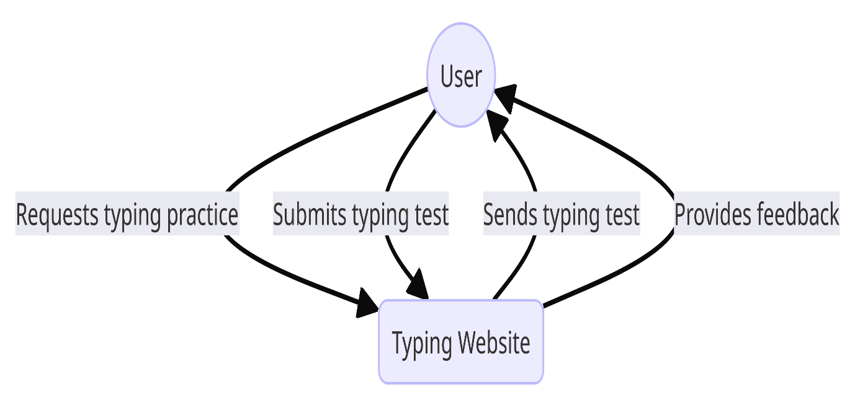

**Level 1**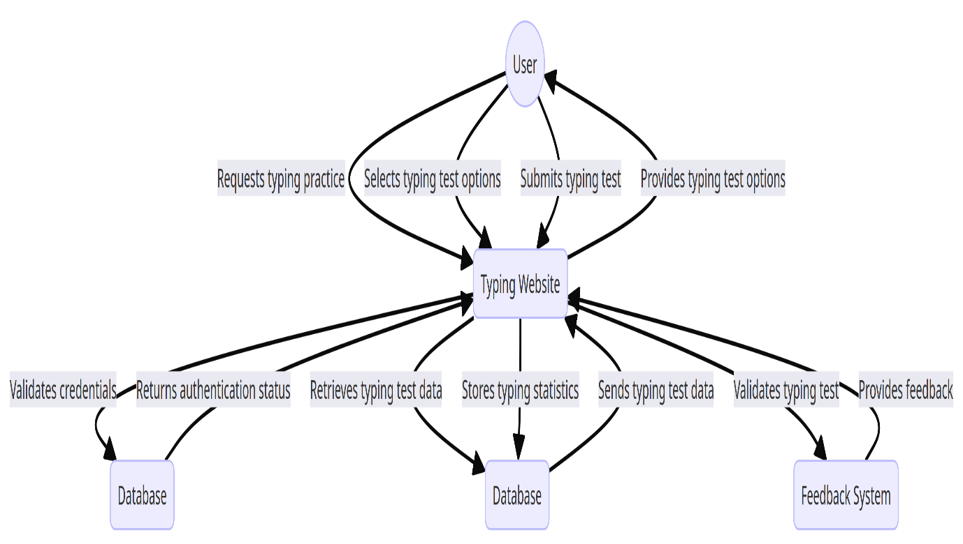

**Level 2**

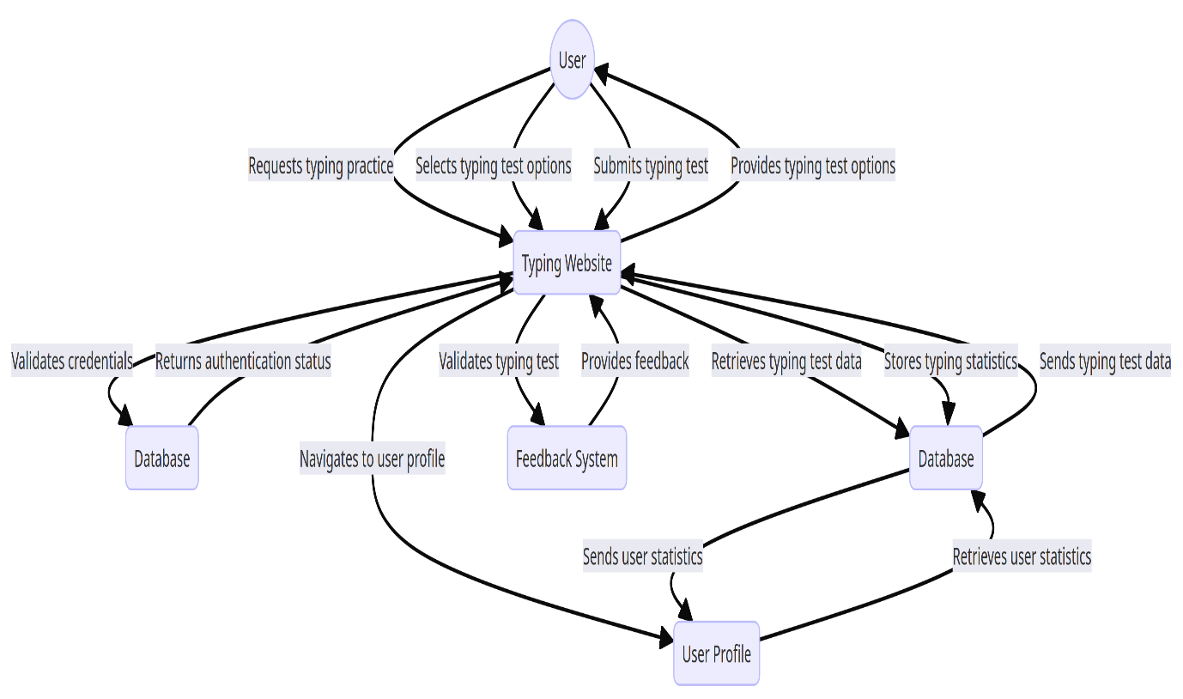

# 8. Dependencies

* The website may rely on external libraries or APIs for certain functionalities (e.g., timer implementation).
* Compatibility with modern web browsers (Chrome, Firefox, Safari, Edge) is required for optimal user experience.

# 9. Assumptions and Constraints

* It is assumed that users have basic knowledge of typing and are familiar with common keyboard layouts.
* Constraints may include limited server resources and bandwidth, impacting website performance during peak usage times.

# 10. Source Code

GitHub Link: [tech1savvy/key-sensei (github.com)](https://github.com/tech1savvy/key-sensei)

Live Link: <https://keysensei.onrender.com>

# 11. System Snapshots

**Main Page**

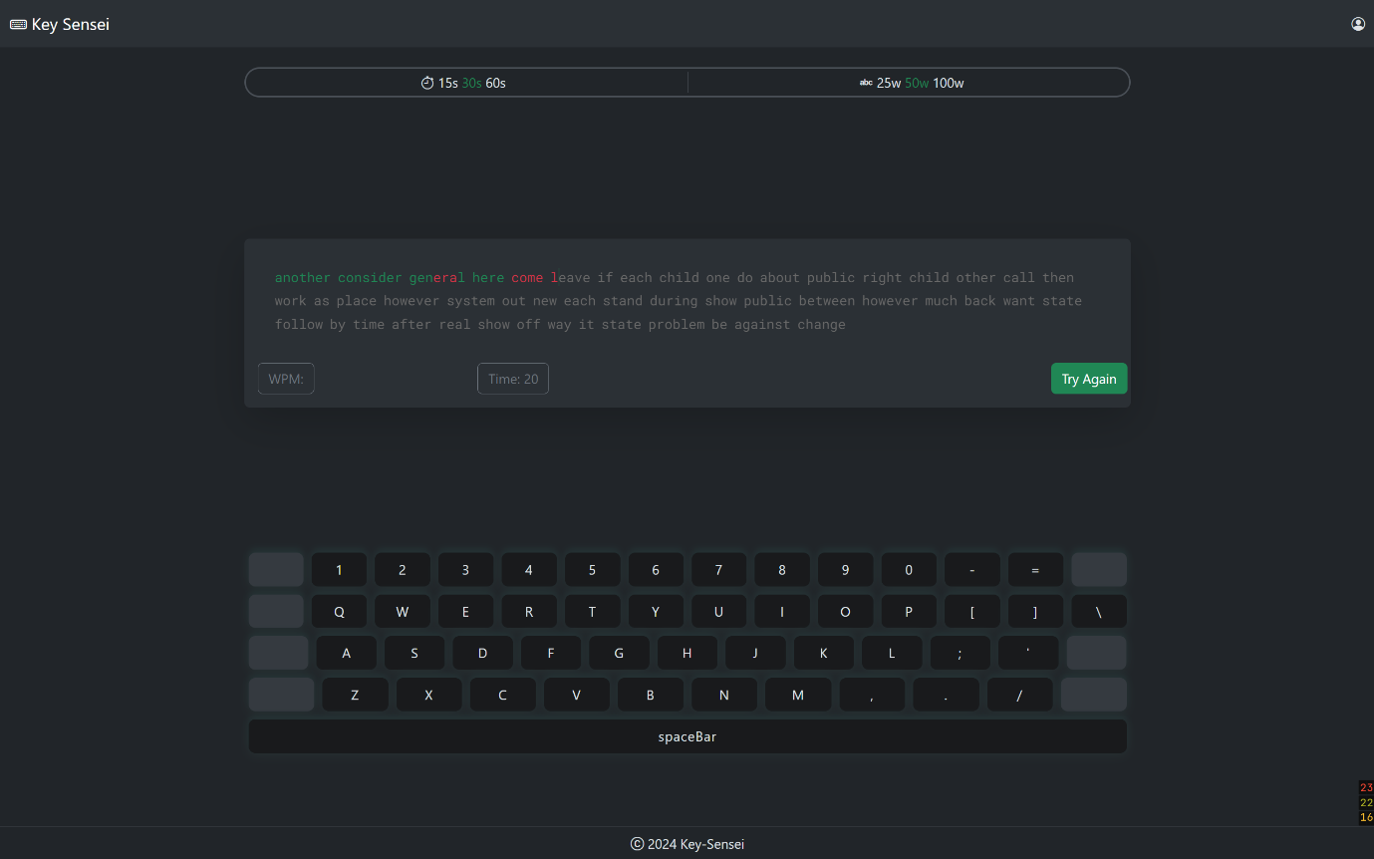

**Sign-In Page**

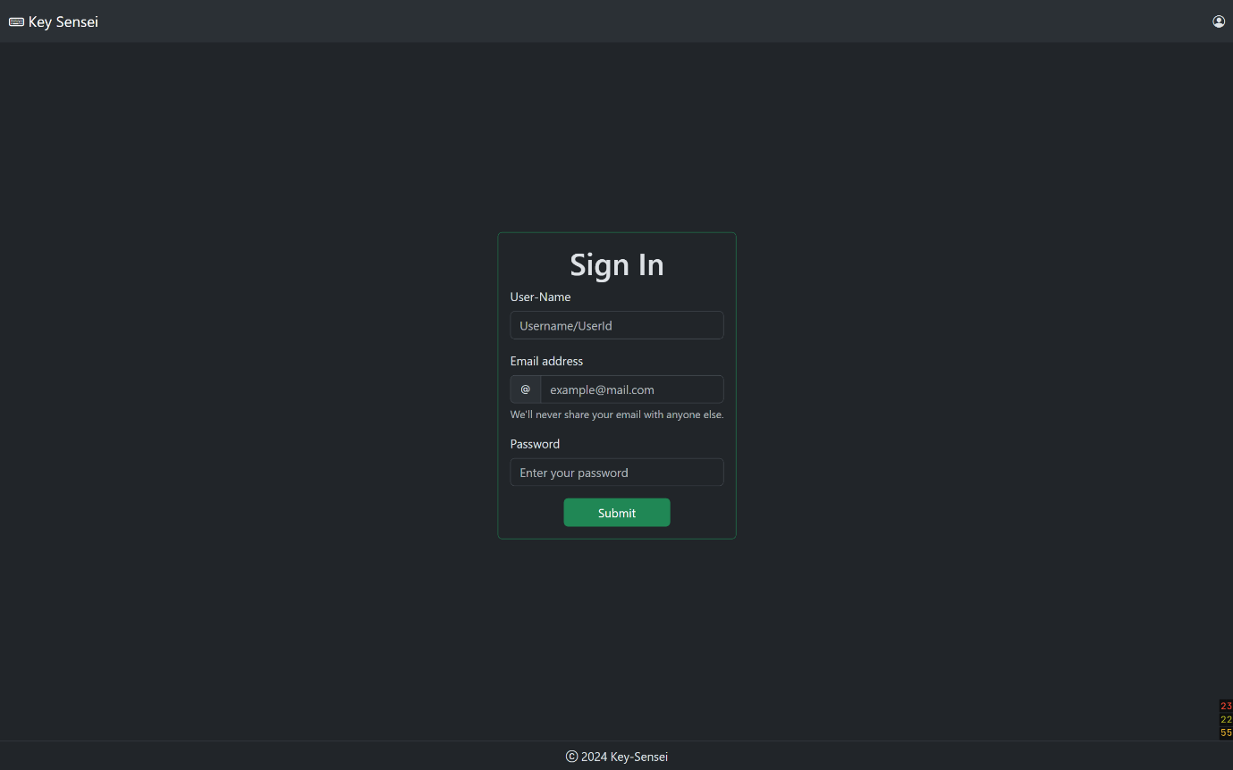

**Login Page**

